Streamlining IT Procurement: Automating
Standard Laptop With
Flow Designer

Problem Statement

To create and automate a ServiceNow Service Catalog process for a Standard Laptop request. The process includes creating a Flow, configuring a Service Catalog trigger, creating and assigning a Catalog Task, setting the required task details and Hardware assignment group, placing a Standard Laptop order, processing the approval, and verifying the generated Catalog Task and request status.

Objective

The main objective of this project is to automate the Standard Laptop request process in ServiceNow. It involves creating a Service Catalog flow, processing the laptop request, obtaining approval, automatically creating a Catalog Task, assigning it to the Hardware team, and verifying the completed request.

Skills Required

ServiceNow Administration
Service Catalog Management
Flow Designer
Workflow Automation
Catalog Task Management
Approval Process Management
Request Management
Basic IT Service Management (ITSM)
Problem Solving
Testing and Validation

Task 1 : Flow

Activity 1 : Create a Flow to Create Catalog task to update the short description after Approval the service Request and it will be Assignment group to Hardware.

1. Open ServiceNow.
2. Go to All → Search for Flow Designer.
3. Open Flow Designer.
4. Click New → Select Flow.
5. Enter the Flow Name: Standard laptop task.
6. Set Application: Global.
7. Set Run as: System user.
8. Click Submit.
9. Click Add a Trigger.
10. In the search bar, type Service Catalog.
11. Select Service Catalog → Click Done.
12. Go to the Actions section.
13. Click Add an Action.
14. Search for Create Catalog Task.
15. Select Create Catalog Task.
16. The Action name/type will be Create Catalog Task.
17. In the Requested Item Record field, select Requested Item Record from the trigger.
18. The Table field will automatically populate as Catalog Task.
19. Enter the Short Description: Laptop need to be Configured.
20. Click Add Field Value.
21. Description: Laptop need to be Configured.
22. Assignment Group: Hardware.
23. Approval: Approved.
24. Leave the remaining fields as default → Click Done.
25. Click Save.
26. Click Activate. When the confirmation message appears, click Activate again.
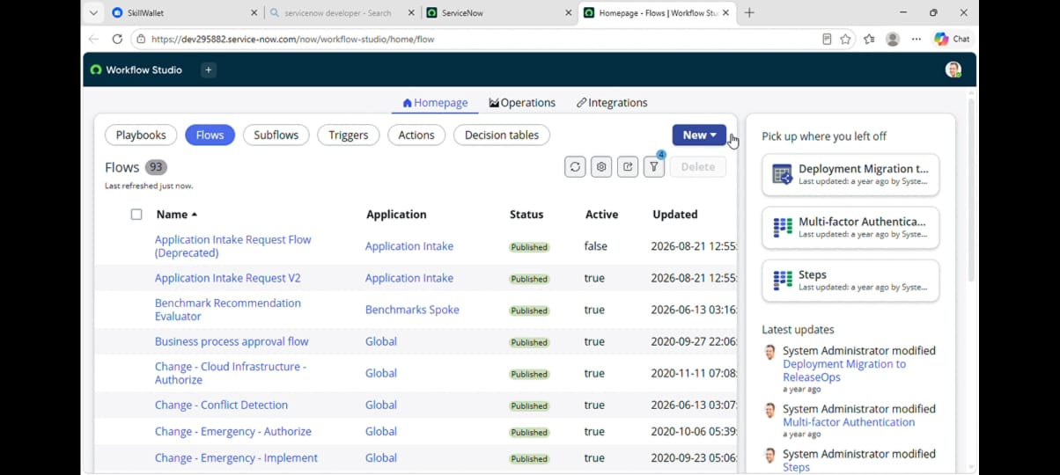
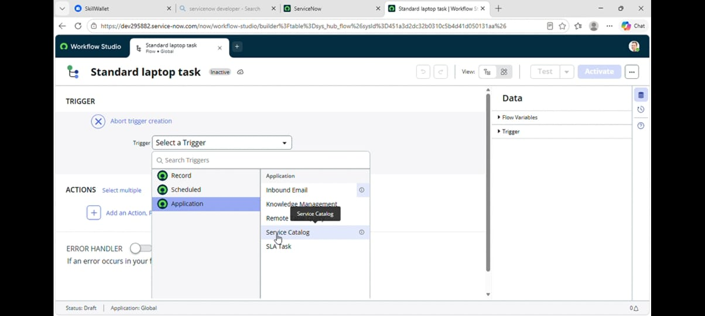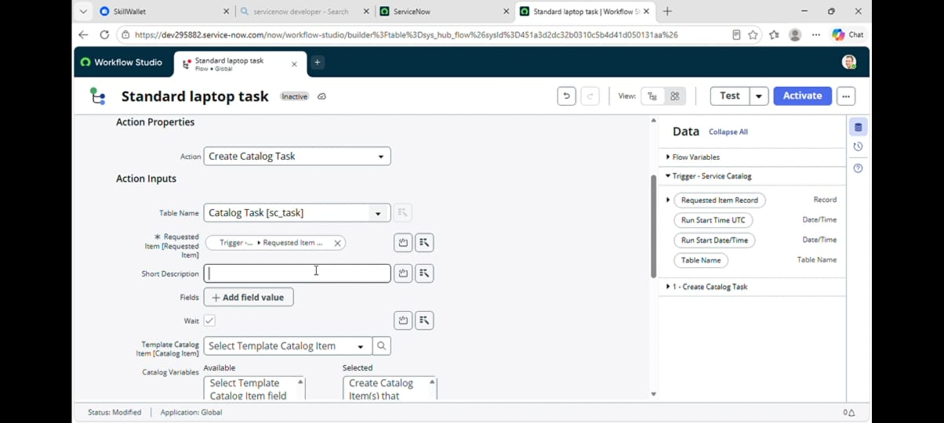

Task 2 : Flow assignment

Activity 1 : Flow Assignment to Standard laptop service Catalog.

1. Open ServiceNow.
2. Click All.
3. In the search box, type Maintain Items.
4. Select Maintain Items.
5. In the Name field/search bar, search for Standard Laptop.
6. Open the Standard Laptop record.
7. In the record, find the Process Engine section.
8. If there are any existing Automations, remove them.
9. Click Add Flow.
10. From the flow list, select Standard Laptop Task.
11. Verify that you have selected the correct flow.
12. ⁠click save
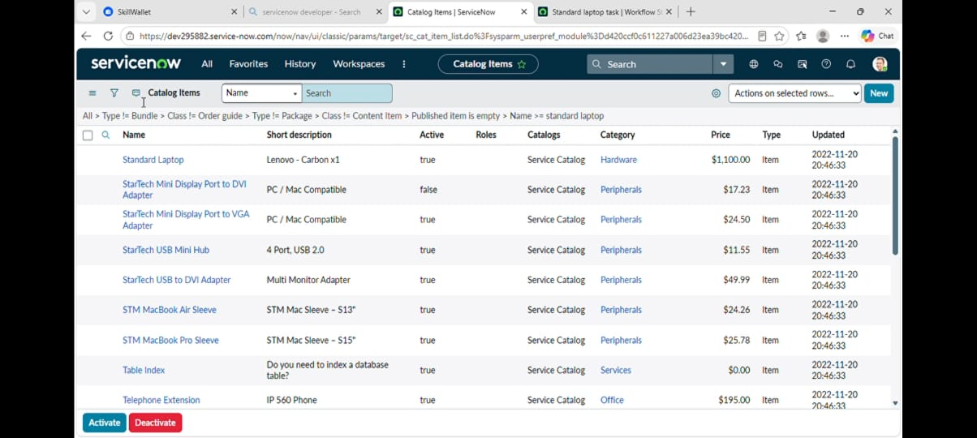
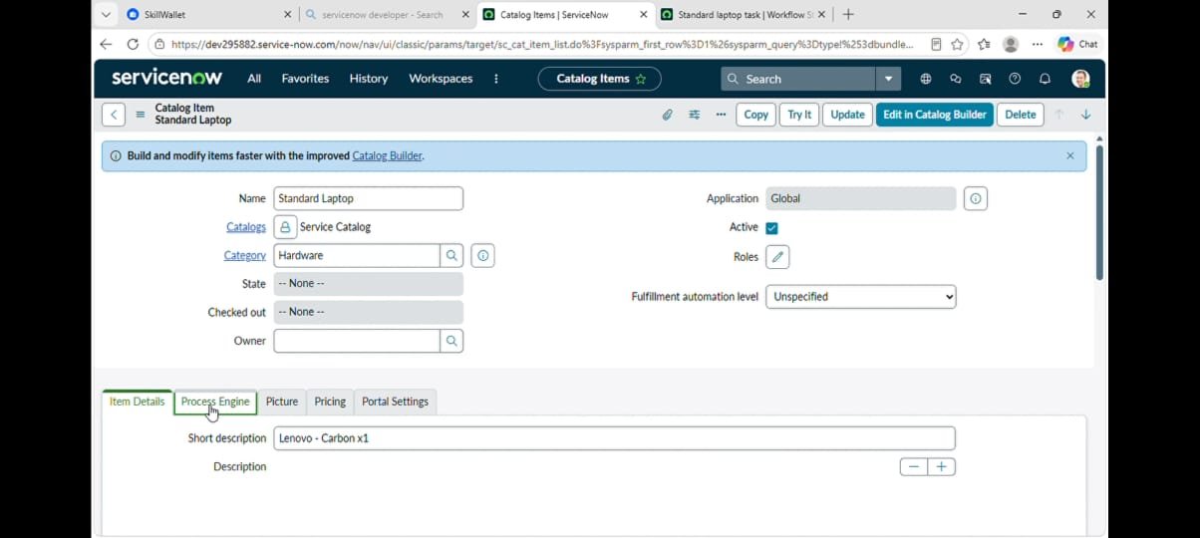
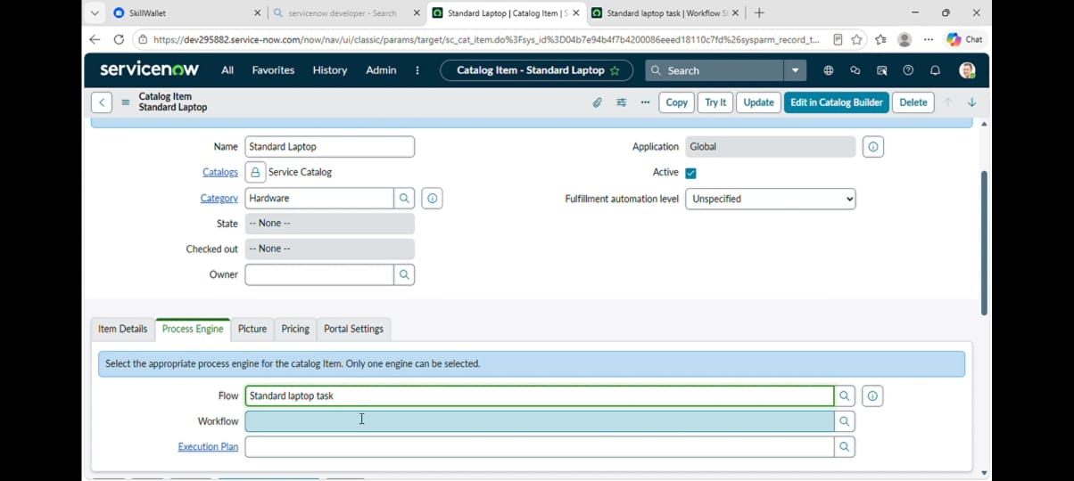

Task 3 : Service Catalog

Activity 1 : Service Catalog for placing order and get Approval

1. Open ServiceNow.
2. Go to All → Search for Service Catalog.
3. Click Service Catalog.
4. Select Hardware.
5. Find and click Standard Laptop.
6. Click Order Now.
7. Once the order is submitted, click on the Request Number.
8. Open the Request record.
9. Scroll down to the Approvers section.
10. Right-click on the Approver record → Select Approve.
11. Click on the Requested Item section.
12. Open the Requested Item record.
13. Scroll down to the Catalog Tasks section.
14. Open the Catalog Task record.
15. Check the Short Description: Laptop need to Configured.
16. Check Assignment Group: Hardware.
17. Check Approval: Approved.
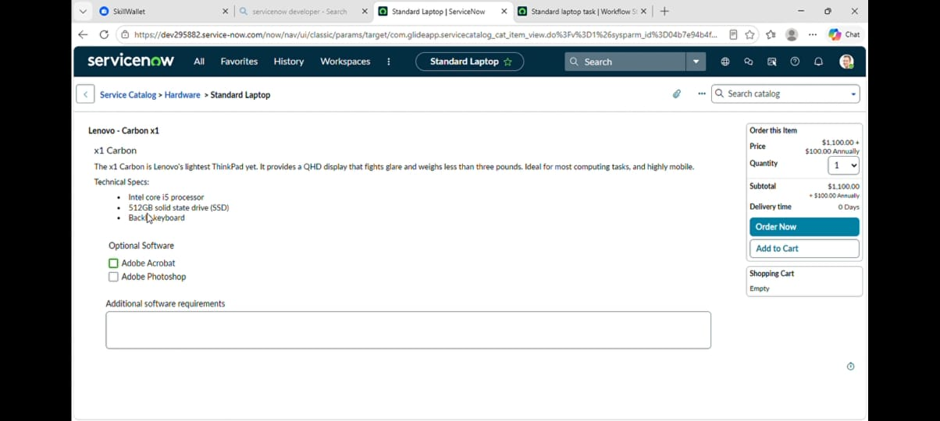
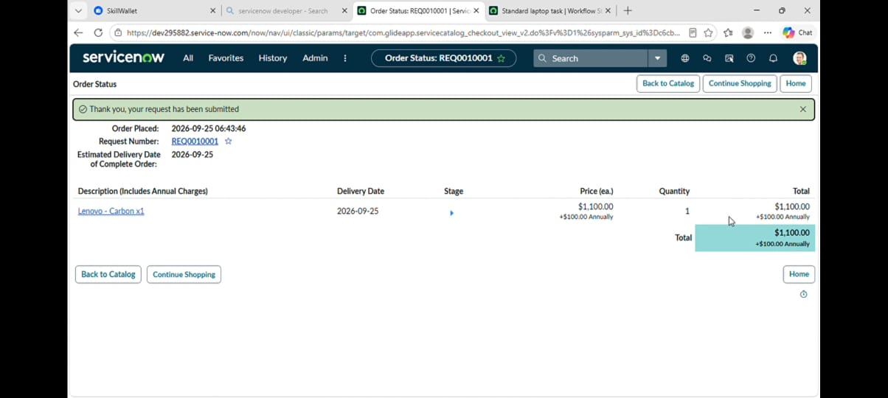

Conclusion

This project successfully demonstrates the automation of a Standard Laptop request process in ServiceNow. A Service Catalog flow was created to manage the request, approval, and automatic Catalog Task creation. The task was assigned to the Hardware group with the required details. Thus, the project helps to make the laptop request process simple, organized, and efficient.

